SPARK*EL
Enrollment Form

Child’s Name: Date of Birth:

Parent/Guardian Contact Information
- Name: Address: Email: Phone:

- Name: Address: Email: Phone:

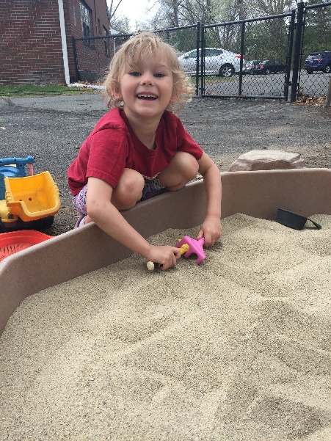
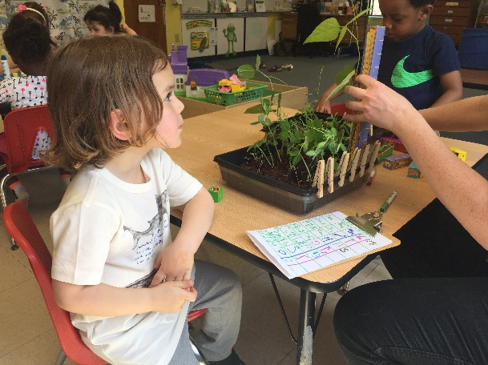
1190 Liberty Street • Springfield, MA 01104 www.academyhill.org • 413.788.0300
SPARK*EL
Summer 2019
Starting June 10th
Emergency Contact Information
Name: Relation:
Work Number: Cell Phone:

Does your child have allergies or other health conditions we need to know about?

June 10-14 Week 1 ◻ June 17-21 Week 2 ◻ June 24-28 Week 3 ◻

Half Day □ Full Day ◻ Before/After Care ◻ Total:
Signature of Parent/Guardian:

For additional information, contact Kathleen Burke at kburke@academyhill.org

Office Only: Rec’d Check # Initials
Enroll NOW! Classes Start June 10, 2019

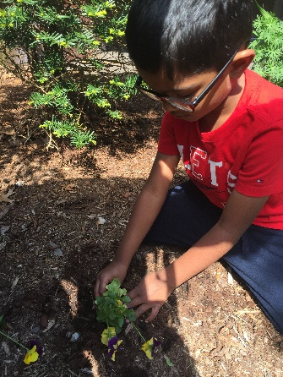
SPARK*EL
Timing
☼ Drop off & Pick up

This is a unique enrichment program for the early childhood set: Pre-K and Kindergarten! Each week features a different subject, including a variety of big ideas for little people. We focus on imagination, exploration, cooperation, and sharing, while enjoying lots of playtime!
June 10-14 Week 1: Science and Investigation

Explore the human body and the five senses, the natural world, and outer space. Through outdoor play and hands-on experiments, we will examine the world around us.

June 17-21 Week 2: Art and Drama

Painting, beading, self-portraits, illustrations, puppeteers, art studies and cartooning are some of the week’s activities. Fields trips to the Eric Carle and/or Dr. Seuss Museum will be included in the program.
June 24-28 Week 3: Engineering and Simple Machines
Early Learners will engage in both individual and group engineering projects. Children will learn about and solve problems with simple machines.
*NOTE: Children must be able to fully toilet themselves.

☼ Morning: 8:45-9:00 a.m.
☼ Afternoon: 4:00-4:15 p.m.
☼ Morning courses: 9:00 a.m.-12:00 p.m.
☼ Lunch: 12:00-1:00 p.m., includes supervised free time.
☼ Afternoon courses: 1:00-4:00 p.m.
☼ Before Care Drop off: between 8:00 a.m. and 8:45 a.m.
☼ After Care Pick up: between 4:15 p.m. and 5:00 p.m.

Please note: Children should not be at Academy Hill before
8:00 a.m. or after 5:00 p.m. If for any reason you must be later than 5:00 p.m., it is very important to call!

Tuition & Fees
Full Days Half Days
☼ $275 for 1 week ☼ $150 for 1 week
☼ $520 for 2 weeks ☼ $275 for 2 weeks
☼ $775 for 3 weeks ☼ $400 for 3 weeks
Before & After Program Care
☼ $15 per day for all or any part of the hours available

