Enrollment Form

Child’s Name: Current Grade:

1190 Liberty Street • Springfield, MA 01104 www.academyhill.org • 413.788.0300
SPARK
Summer 2019
For students currently in Grades 1-8

Parent/Guardian Contact Information
- Name: Address: Email: Phone:

- Name: Address: Email: Phone:

Emergency Contact Information
Name: Relation:
Work Number: Cell Phone:

Does your child have allergies or other health conditions we need to know about?

_____________________________________________________________________

Dynamic Enrichment in
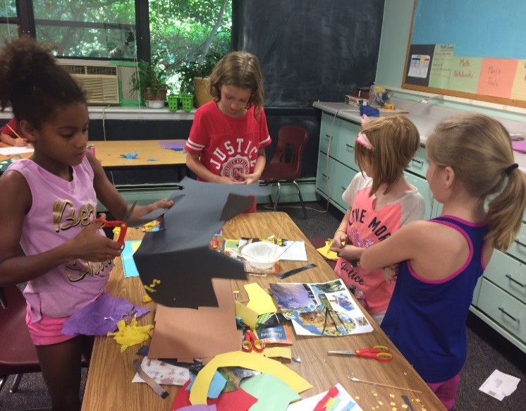

☼ Science
☼ Math
☼ Arts
☼ Recreation
☼ Technology
June 10-14 Week One ◻ June 17-21 Week Two ◻ June 24-28 Week Three ◻

Half Day □ Full Day ◻ Before/After Care ◻ Total:

Signature of Parent/Guardian: ____________________________________________
Starting June 10th
Circle your selections and submit with payment!

Office Only: Rec’d Check # Initials

Schedule
*Please circle to indicate block choice.
A Block  9:00 - 10:15 a.m. | B Block  10:45 - 12:00 p.m. | C Block  1:00 - 2:15 p.m. | D Block  2:45 - 4:00 p.m.
Week One: June 10 - 14
Hiking/Exploring | Fitness Games | Yoga | Board Games
Kids Coding | Get S-M-Art | Kids Coding | Nature Art
Stock Market | Stock Market | The City | The City
Week Two: June 17 - 21
Hiking/Exploring | Fitness | Board Games | Yoga
Grand Camp | Kitchen Chemistry | Kids Coding | Kids Coding
Creative Art | Game Show | Card Games | Game Show
Week Three: June 24 - 28
Hiking/Exploring | Fitness Games | Board Games | Yoga
Grand Camp | Kids Coding | Kids Coding | Game Show
The Farm | The Farm | Stock Market | Stock Market

SPARK
Academy Hill’s SPARK summer program consists of dynamic enrichment courses designed to ignite the interests of students in meaningful ways and to enliven their natural curiosity and sense of wonder.
The Program is grounded in the belief that students’ abilities and talents can be latent, emergent, or manifest. SPARK provides the stimuli and support that helps students to discover and develop their creative potential, strengths, and interests.
Students can choose from an array of courses, in which staff act as guides-on-the-side during the learning journey. We also strive to foster the social and emotional well-being of our students, and understand that students have a range of learning differences.
Academy Hill is a private day school for motivated children. These courses are also open to the general public. Class sizes are intentionally small, and therefore enrollment is limited.
We sincerely hope that you and your child find being a part of SPARK a positive experience.
If you have any questions or comments, please feel free to contact the program coordinator, Kathleen Burke, at kburke@academyhill.org.

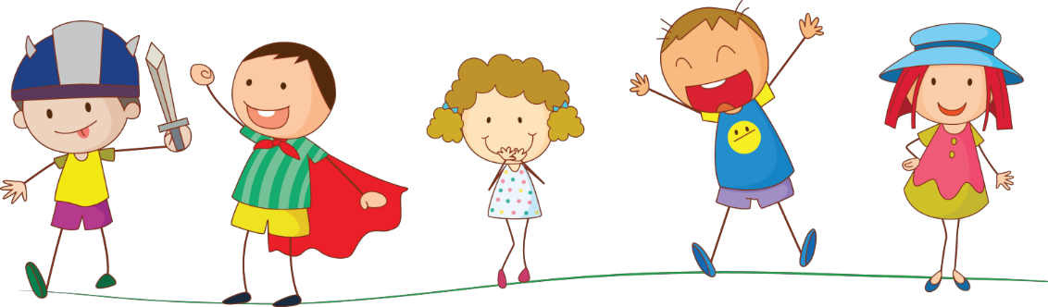
Enroll NOW!

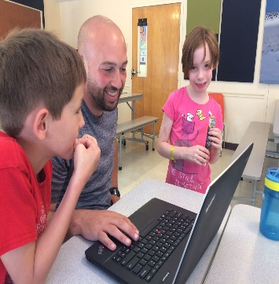

Timing
☼ Drop off & Pick up

Important Information

☼ Morning: 8:45-9:00 a.m.
☼ Afternoon: 4:00-4:15 p.m.
☼ Morning courses: 9:00 a.m-12:00 p.m.

☼ Lunch: 12:00-1:00 p.m., includes supervised free time.
☼ Afternoon courses: 1:00-4:00 p.m.
☼ Before Care Drop off: Between 8:00-8:45 a.m.
☼ After Care Pick up: Between 4:15-5:00 p.m.

Please note: Children should not be at Academy Hill before 8:00 a.m. or after 5:00 p.m. If for any reason you must be later
than 5:00 p.m., it is very important to call!
Tuition & Fees

Full Days Half Days

☼ $275 for 1 week ☼ $150 for 1 week
☼ $520 for 2 weeks ☼ $275 for 2 weeks
☼ $775 for 3 weeks ☼ $400 for 3 weeks

Before & After Program Care
☼ $15 per day for all or any part of the hours available

Students need the following items daily:
☼ Backpack or similar
☼ Lunch
☼ Two snacks
☼ Sunscreen
☼ Insect repellent
*Student may leave a change of clothing at the school.

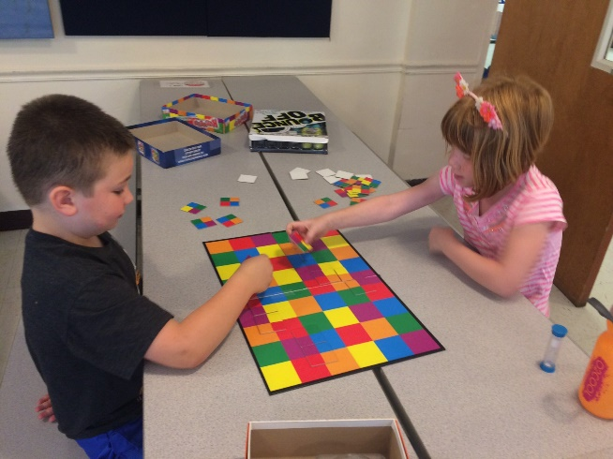

☼ A student health form is required prior to attendance. Known allergies must be listed on the health form.
☼ Enrollment is contingent on payment.
☼ Classes with under 3 students may be cancelled. If so, you will be notified and offered another selection or refund.

Board Games (Open to All)
Certain games have been played for generations, while other fun games hit the market daily. Learn some classic familiar games, explore some new games, and try your hand at inventing your own game, too!
Card Games (Grades 4-8)
Learn how to play games with strategy, skill, and a bit of luck. Hearts, Oh No!, and Canasta will be some of the card games we learn together.

Creative Art (Grades 3–8)

Each day we will explore and create with different materials and art styles. Join the fun and add your artistic flair!

Fitness (Open to All)
Learn safe stretching exercises before beginning your fitness program. Calisthenics will be incorporated into your morning routine.

Fitness Games (Open to All)
Soccer, stickball, flag football, street hockey, badminton and basketball will round out the sports day!

Game Show Returns (Grades 2-8)
Do you like to watch games shows and think, “I could do that?” Well, now is your chance! We will play Minute to Win It, Are you Smarter Than a 5th Grader?, and Wheel of Fortune, to name a few. Come join the fun and excitement, and test your knowledge and skills.

Get S-M-Art (Grades 3–8)
That’s what happens when you combine Science, Math and Art. Explore creative projects like hexaflexagons. Many unique activities make this a popular SPARK.
Grand Camp (Open to All)
Fun without technology or screens? Play hands-on games with spoons, marshmallows, tents, and other creative materials!

Hiking and Exploring (Open to All)

Venture into the woods behind the school each morning to explore, look for wildlife, identify plants, and appreciate the wonders and surprises in our backyard.

Kids Coding (Open to All)
Use fun programs like LightBot, Kodu, Code.org or Scratch to learn logic and coding. You can even build a world or design a game of your own and share it with the world. Levels are based on prior coding experience. (Only one Time Block Permitted Daily)

Kitchen Chemistry (Open to All)
Come ready to get your hands dirty with tasty experiments and discover how chemistry is part of preparing foods you enjoy!

Nature Art (Open to All)
Inspired by the work of Andrew Goldsworthy, students will create one-of-a-kind artistic pieces using what we find around us in nature. From leaf rubbings to fairy houses, making baskets or stone cairns, artists will create beautiful pieces using the world around us.

Stock Market (Grades 4-8)

Learn how stocks and commodities are bought, sold and traded around the world, and why companies sell shares. Test your skills by building your own portfolio and chart its progress. Will you earn a profit? No specialized math skills required.

The City (Grades 4-8)

Discuss some of the great cities of America, past and present. What unique problems do cities face? What do you know about the local city of Springfield?

The Farm (Grades 4-8)

Did you know that at one time more Americans lived on farms than in cities? Farms have transformed with trends, such as organic practices and producing specialized items. Discover how local agriculture can support food choices.

Yoga (Open to All)
Learn basic yoga movements to incorporate into everyday routines. Stretch and strengthen your body and mind while learning to be calm, cool, and collected. Use and control your energy in productive ways.

